**For Immediate Release February 22, 2023**

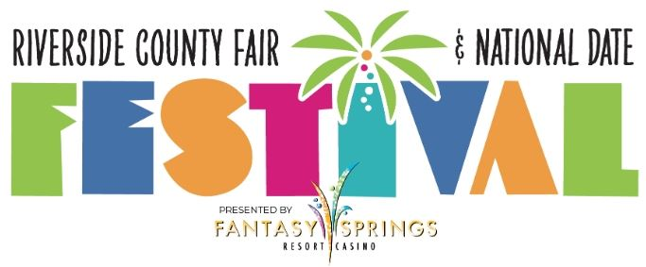

**RIVERSIDE COUNTY FAIR & NATIONAL DATE FESTIVAL**

**DELAYS OPENING UNTIL 5 PM ON WEDNESDAY, FEBRUARY 22**

**Indio, CA –** Due to last night’s weather conditions, the Riverside County Fair & National Date Festival will delay opening today until 5PM.

Said Chris Pickering, Founding Partner of Pickering Events: “Our business partners have requested additional time to prepare the Fairgrounds for our guests following strong overnight winds. Wednesday's opening of the Riverside County Fair & National Date Festival presented by Fantasy Springs Resort Casino will be pushed from 3:00 p.m. to 5:00 p.m. Military Appreciation Day complimentary admission will continue, though the 5:00 p.m. flag ceremony has been cancelled. Limited complimentary reserved seating tickets to all upcoming grandstand shows for the remainder of the Fair & Date Fest are available to veterans through [VetTix](https://www.vettix.org/) on a first-come, first-served basis.”

The Fair will be open until 10 PM tonight.

**For more info, please email** [**Merry@MPowerMedia.com**](mailto:Merry@MPowerMedia.com) **or** [**Maryann@MPowerMedia.com**](mailto:Maryann@MPowerMedia.com) **or call:**

**Merry Aronson Maryann Ridini Spencer**

(818) 720-1063 cell (818) 884-0104 cell

(818) 760-1502 office (818) 760-1502 office